Hosting ftp server on the ec2 linux

We will host the ftp server on the previously created ec2 instance named as ‘server’, and give it all required permissions in the security group for the ftp server. Then launch (connect) the instance.

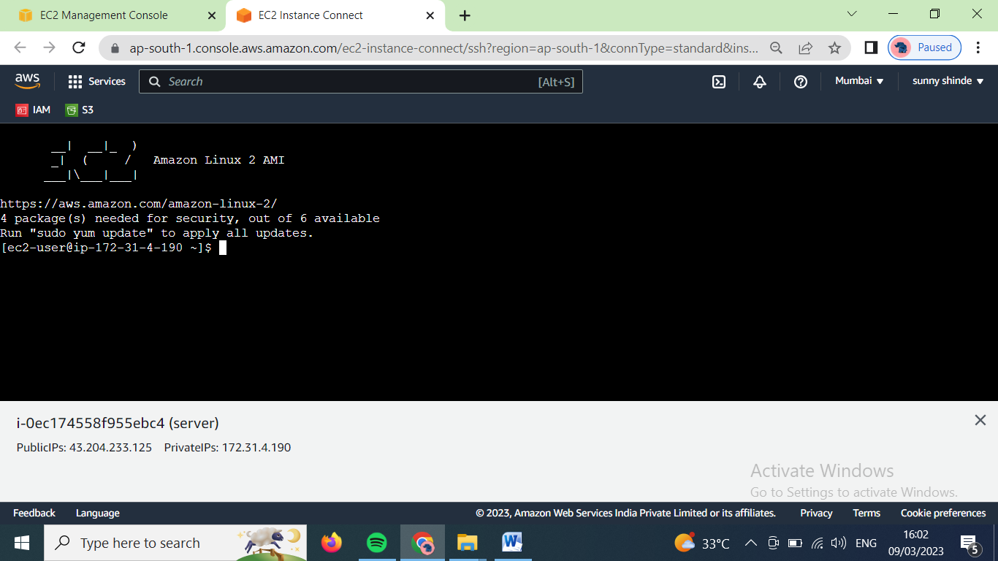

Install vsftpd using ‘yum install vsftpd –y’ command

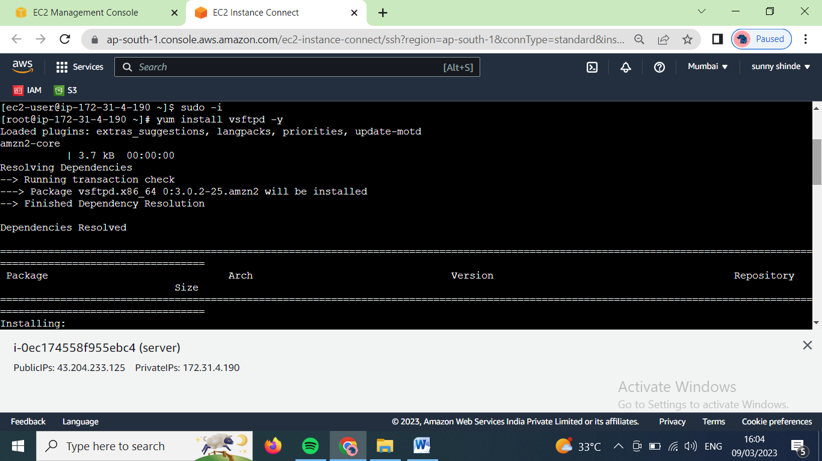

Install ftp using ‘yum install ftp -y’ command.

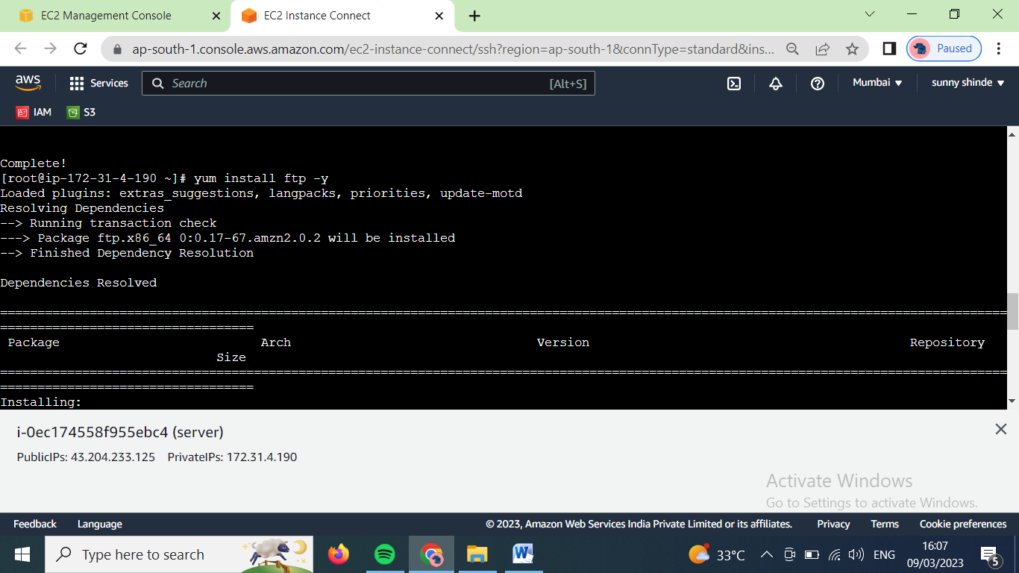

Now to configure the vsftpd use ‘vim /etc/vsftpd/vsftpd.conf’

And uncomment the line ‘#anon_upload_enable=YES’

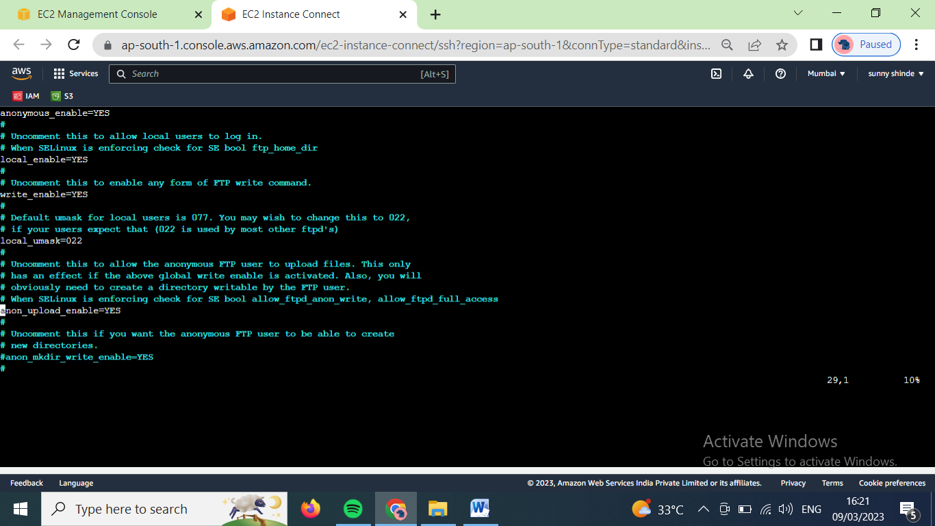

Now lets change mode of selinux to the inforcing using ‘vim /etc/selinux/config’ command.

The reboot the linux machine to confirm the changes. In this case we will stop and start instace.

Now the documentation path of the fpt was created in /var/ftp/

Change directory using ‘cd /var/ftp/’

Get the list of boolines related of ftp using ‘getsebool -a | grep ftp’

Then on the following booliens using command ‘setsebool ftpd_full_access on’, ‘setsebool ftpd_anon_write on’

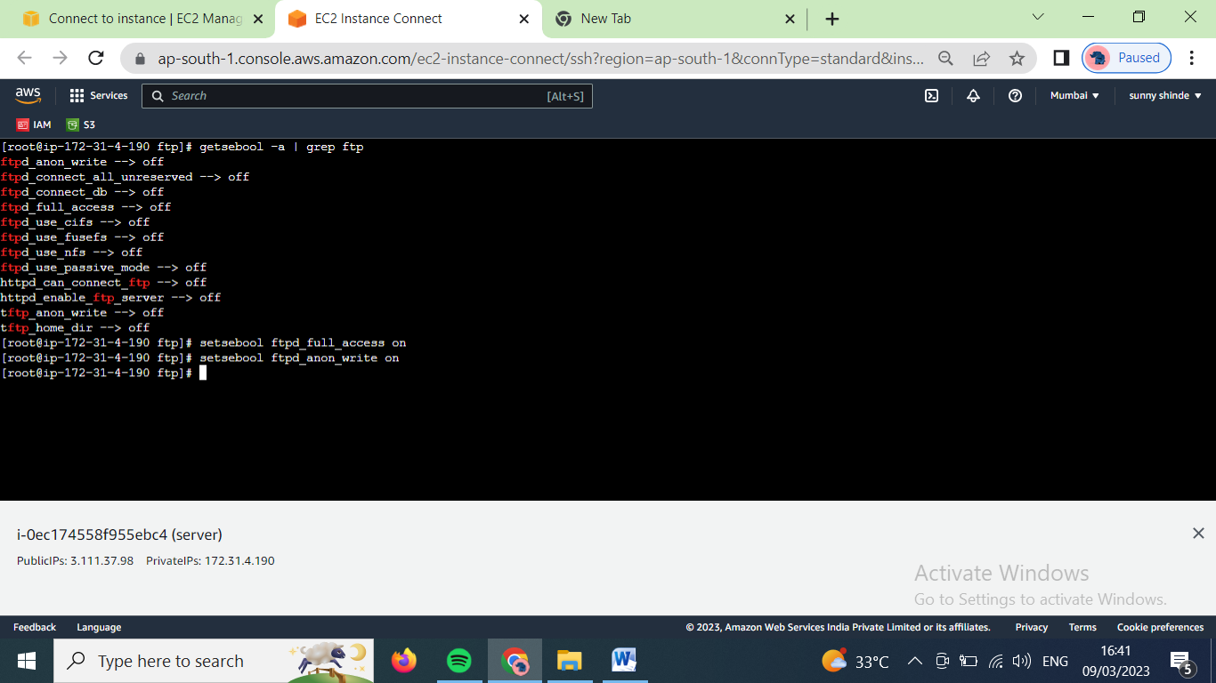

Now create a directory. Create files in it and give that directory 777 permissions.

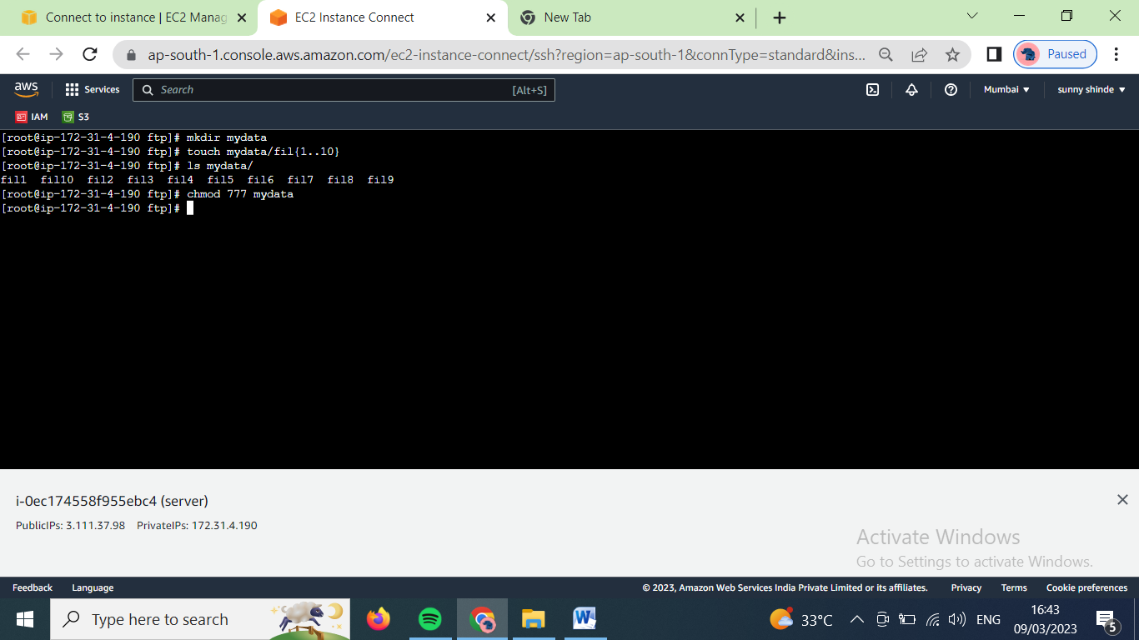

Now start the ftp server using ‘systemctl start vsftpd’ command.

Now to configure the vsftpd use ‘vim /etc/vsftpd/vsftpd.conf’

Add following line at the last 🡪 pasv_promiscuous=YES

Then refresh the vsftpd using ‘systemctl restart vsftpd’

Now open the client machine

Install ftp service using ‘ yum install ftp’ command

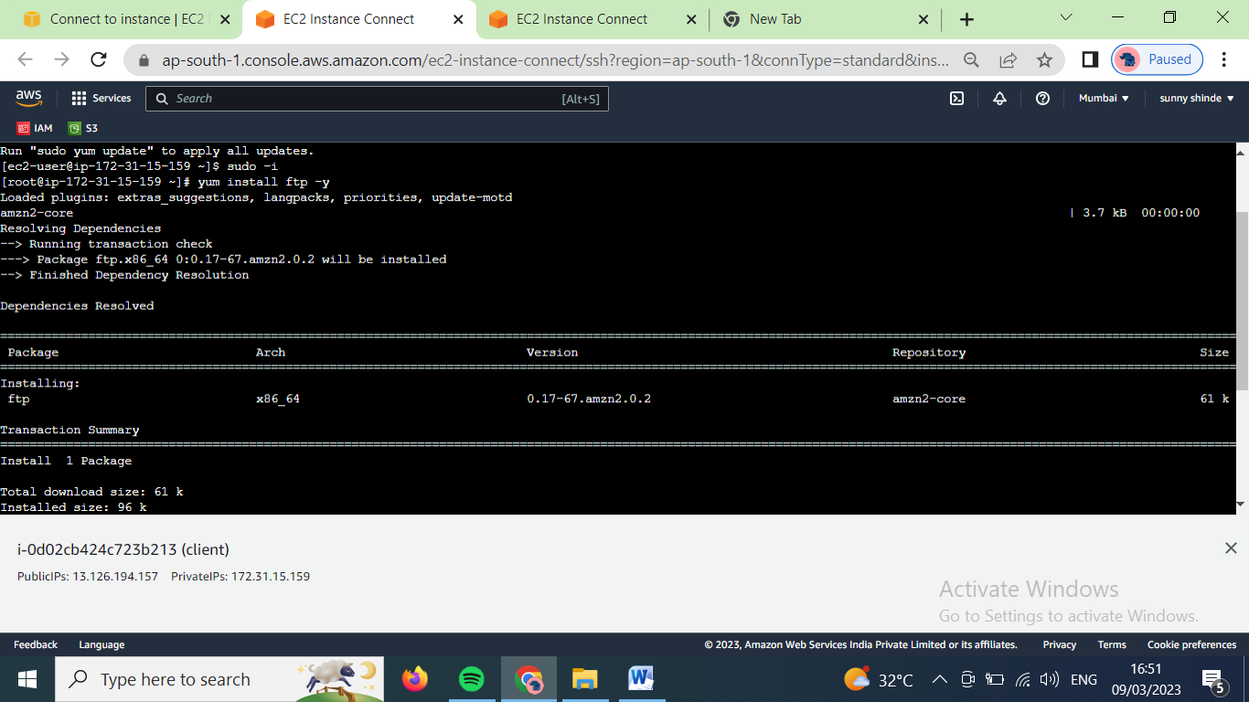

Now use command ‘ftp <server machine ip>’

Enter name of user

Enter password (in case of ftp user, just enter )

Now we are log in ftp promt

